**Project Development Phase**

**Performance Test**

|  |  |
| --- | --- |
| Date | 20 May 2023 |
| Team ID | NM2023TMID22230 |
| Project Name | Project - SQUID: Street Quality Identification |

**Performance Testing:**

PYTHON OUTPUT SCREENSHOT:

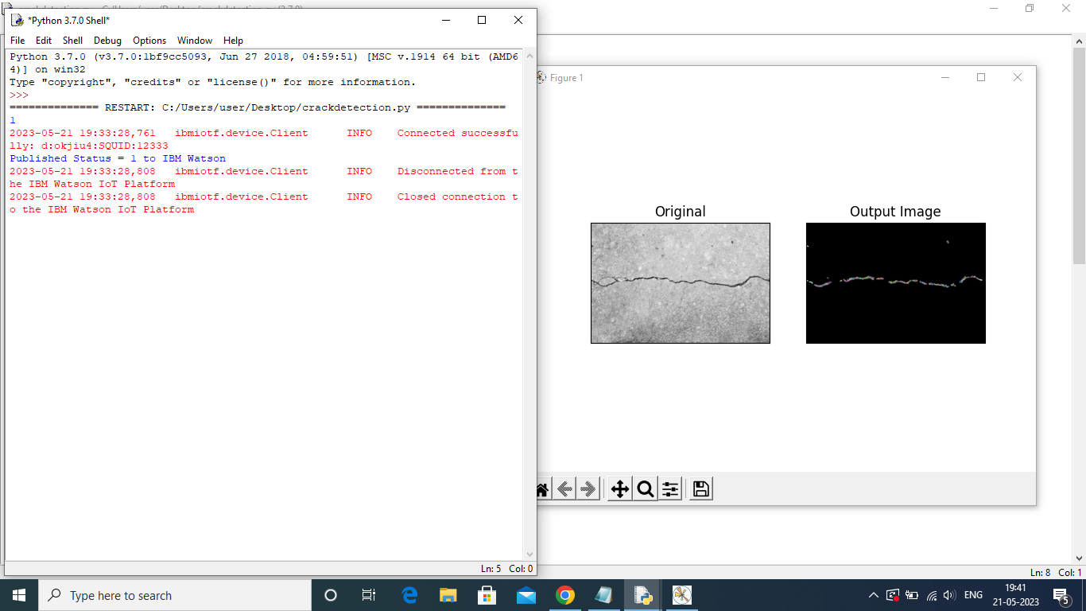

IBM ACCURACY SCREENSHOT:

